What to do?

1. Find Grammer.
2. Find (first/follow)”With print them”.
3. Parsing table.
4. Stack and buffer.
5. Finally(Try cases) and try them.

FIRST:

S→0AB

A→1A/1

B→aB/a

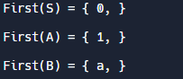

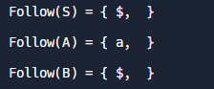

SECOND:

A→aB

B→0B | bc

C→ bC | #

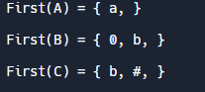

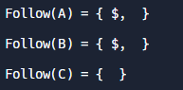

Third:

A→1B

B→0B/0C

C→1D

D→ #(epsilion)

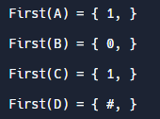

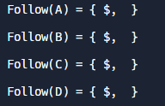

4th:1^2n,n>=0

A→#/1B

B→1A

____ERORR 404____



5th:

A→0C

C→0C/1A/#

____ERORR 404____



6th:

A→cT

T→bT|#



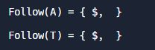

7th:S→Sbm|Str|;|+|9|+|n

S→;K/+K/9K/nK

K→bmK/trK/#





8th:

A→aB

B→bB/bC

C→cC/#

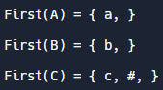

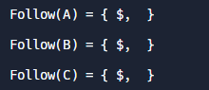

9th:

A→aB

B→bC/0B

C→bC/#

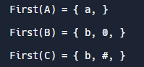

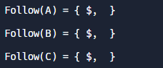

10th:

S→101A

A→0a|B|0A

B→1B|1

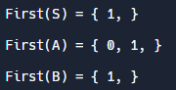

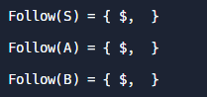

__________________________________________________________

Nice one:L(G)={m(a^n)(b^n+1)(c^m+1)d,n>=1,m>=1}

S→mAbBcCD

A→ aA | a

B→ bB | b

C→ cC | c

D→ d

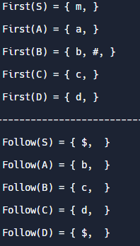

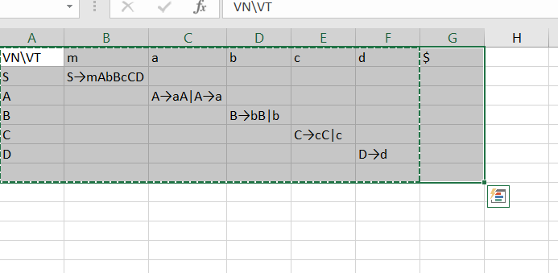

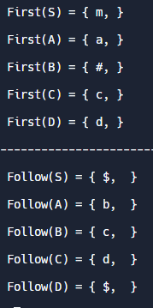

S→mAbBcCD

A→ aA | a

B→ #

C→ cC | c

D→ d

***Theory Project***

***CFG***

S→mABcD

A→ aA | #

B→b

D→ d



